The Personality Compass

Everyone has some characteristics from each of the four types, but one will capture the essence of your personality more accurately than the others. That is your dominant type. No one type is better than another, they’re all just different.
NORTH Natural leader; Goal-centered; Fast-paced; Task-oriented; Assertive; Decisive; Confident; Determined; Competitive; Independent. North people have a “go-go-go” “let’s get this done” attitude.

WEST Paying attention to detail —likes to know the who, what, when, where and why before acting. During directions, West people are the ones who have a million questions and want to get every little detail right.
Natural risk taker; Idea-centered; Creative; Innovative; Flexible; Visionary; Spontaneous; Enthusiastic; Free-spirited; Energetic

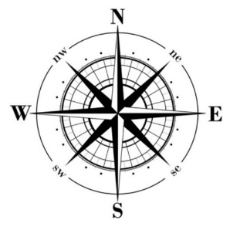
EAST Speculating – likes to look at the big picture and the possibilities before acting. East people can be dreamers and visionaries. They’re the people who are coming up with cool, random ideas, but don’t always stick to the details.

SOUTH Caring – likes to know that everyone’s feelings have been taken into consideration and that their voices have been heard before acting.

North, South, East and West
Decide which of the four “directions” most closely describes your personal style. Then spend 15 minutes answering the following questions as a group.
1. What are the strengths of your style? (4 adjectives)
2. What are the limitations of your style? (4 adjectives)
3. What style do you find most difficult to work with and why?
4. What do people from the other “directions” or styles need to know about you so you can work together effectively?
5. What do you value about the other three styles?
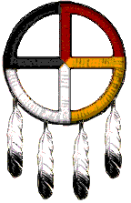
History
The Personality Compass draws from a Native American Indian–based practice called the Medicine Wheel or the Four-Fold Way. In the Four-Fold Way, the four directions are described as warrior (north), healer (south), teacher (west), and visionary (east). All directions have profound strengths and potential weaknesses, and every person is seen as capable of growing in each direction. Each direction has a primary “human resource,” including power (north), love (south), wisdom (west), and vision (east), as well as primary struggles, associated with loss or difficulty. Each person can access the gifts associated with each direction; through work, ritual, a variety of practices; in order to become more whole.

